Unite at the FCA – Hybrid working survey

Introduction – Our stance

We say that the FCA should move away from rigid quotas for office working that are imposed on all employees. Instead, office working requirements should be flexible and negotiated at a local level based on the objective, evidence-based needs of different business areas.
There have been many reports recently that Exco is preparing to increase the 40% requirement. We have also heard that some managers have been revoking locally agreed flexible ways of working.
The FCA has recently conducted a staff survey on this subject. It is not clear how the results of this survey will be used and whether they will be published. Unite has therefore conducted its own independent survey and is happy to disclose the results to anyone who wishes to see them.
We say that the concept of imposing an office working quota, whether 40% or otherwise, is misconceived. A uniform quota is not consistent with treating staff as responsible professional adults. Nevertheless, the status quo of 40% represents an acceptable compromise. We say that an increase in the quota would be a mistake because:
1. Commuting is expensive for many people, and compulsorily raising their time in the office reduces their income as well as their quality of life. Another pay cut would be bad news at the best of times; and this is not the best of times. The survey has also revealed that commuting puts people off from going the extra mile and working beyond their contractual hours.
2. There are wide-ranging D&I implications to a forced return to the office, most obviously in respect of disabled people and carers (who are disproportionately female). There are also, as our survey reveals, more general health concerns with increased office working going beyond people with statutory disabilities.
3. Forcing people to work where bosses can see them is contrary to a modern, progressive working culture. We are concerned that this would have a negative effect on recruitment and retention at the FCA, as well as more generally on morale, which in turn is linked to productivity and organisational effectiveness.

The survey results

The survey was completed by 450 people, of whom 117 were people managers (PMs) and 333 were not people managers (NPMs).

Right now EXCO want you and your colleagues to be in the office 40% of the time. Thinking of yourself is that:
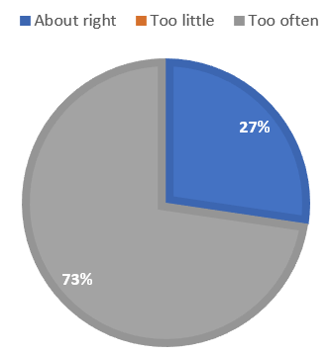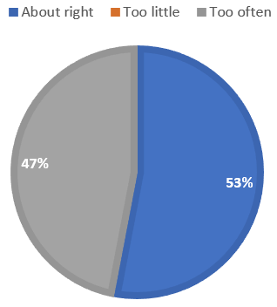
The chart on the left relates to NPMs and the chart on the right to PMs. It can be seen that PMs were much more likely to think that the 40% quota is about right. Most NPMs thought that it was too high. No-one in either category thought that it was too low.

Thinking of yourself, what type of working arrangement would be ideal for you?
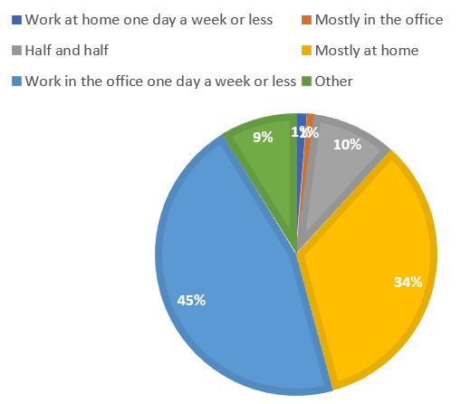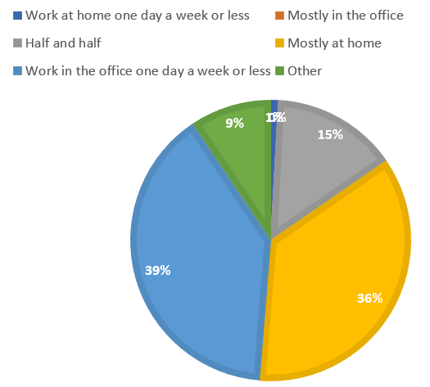
NPMs on the left, PMs on the right. This time, the results are similar for both groups – a plurality in each case favoured working in the office for 1 day a week or less (represented by the medium blue segments – not to be confused with the much smaller dark blue segments denoting working at home for 1 day a week or less). The second most popular option in each case was working mostly at home.
As for those who chose “Other”, the most popular answer (12 responses) was along the lines that a fixed quota should not be imposed. Specific responses included the following:
I would like to have flexibility to decide for myself - I'm an adult and see the benefit of being there sometimes, but also don't see the point in going if I'm just going to be on calls all day, just to 'show my face'.
I want the flexibility to choose based on team tasks, my work and family. Not to adhere to a fixed percentage. The percentage of time in the office should be the output of having considered where, when and how I need to work.
Flexible depending on business need and role - so for me I would probably go into the office whenever I have meetings but stay at home when I need to get my head down and work on [REDACTED]. Giving people a quota was the wrong approach, we are adults who deserve the freedom to make the best choice for ourselves, our team and our careers.
Flexibility for everyone and what suits their own circumstances at the time. People should be allowed to decide as responsible adults, making a rule about when to come in, given the last 2 years indicates a lack of trust.
Home based, with 2 consecutive days a quarter where everyone comes in to network and socialise whilst on site. (This is something I read about from a think tank on the future of the office). They said the 2 days should be on cascading information, team building, workshops and lectures with an overnight social element.

Compared to when you were office based, how easy is it now to….
….keep in touch with colleagues? ….keep in touch with external contacts?
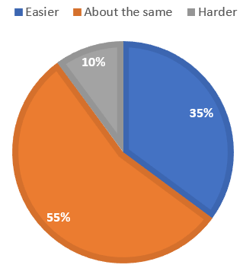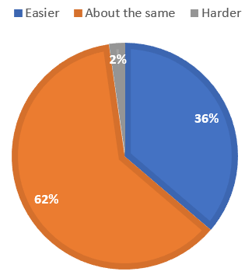
Significant majorities reported that hybrid working has made no difference to their ability to keep in touch with others internally and externally. Large minorities reported that it has made it easier.

….be productive in your role? ….be productive in your team?
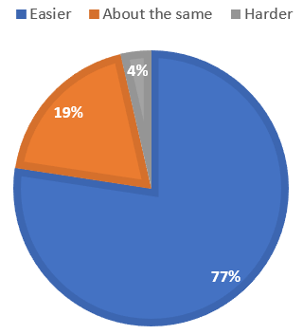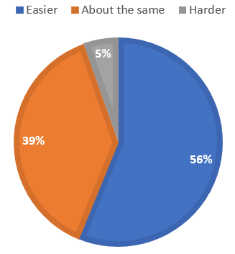
Large majorities reported that they find it easier to be productive. Very few respondents reported that it has become harder.

….have effective meetings?
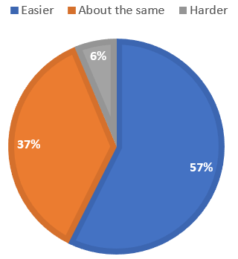
Perhaps unsurprisingly, the results for this question were almost the same as the results for the immediately preceding question.

….manage family responsibilities? ….look after your physical and mental health?
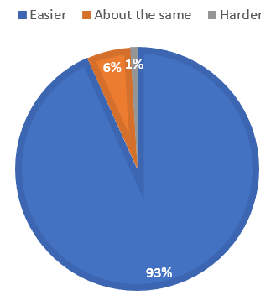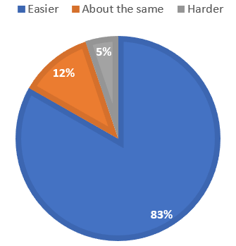
These figures speak for themselves. The impact of hybrid working on people is almost uniformly positive from the point of view of family life and health. It is clear that impacts on health go far beyond the population of people with statutory disabilities who would be entitled to hybrid working as a reasonable adjustment.

If everyone had to come into the office more often than now, what would it mean for you?
The figures for the positive statements suggested to respondents are dwarfed by those for the negative ones. The number of people who would look to move from the FCA is particularly striking.
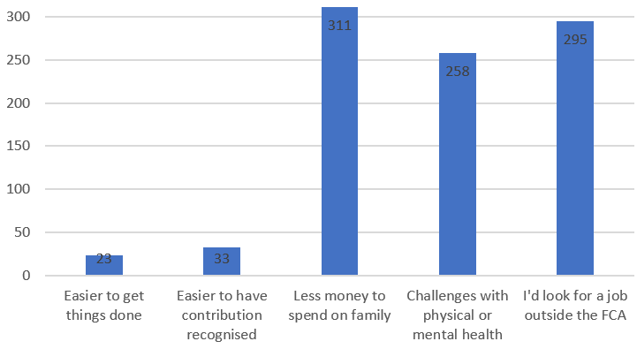
The free text comments that were made included the following:
Coming back to the office has had a very positive impact on my mental health, but even so, 2 days a week feels right and more than that would be challenging
Since starting a family my commute has got longer and more expensive. If I was forced to come in to the office more than my current circumstances allow, then I would have little option but to find another employer.
I'd have to spend a lot of time and money on commuting. I also find the office is very distracting as it is open plan.
The FCA has been banging on about how it pays less than industry but the work life balance makes up for it. If we’re in the office just as much, if not more, than industry, there will be no benefits to working at the fca compared with elsewhere. Might as well leave and get paid 50% more
I'd be less willing to put in extra hours if needed... as I'd be conscious of travel time. When you work from home, a bit of extra effort/time isn't a challenge as you haven't got to worry about transport.
I think the benefits of being able to work flexibly from home are powerfully illustrated by an actual example I experienced on 31 May. I had [REDACTED] and was very ill on the evening of 30 May and morning of 31 May. Ideally, I probably would have taken 31 May off sick, but was unable to do this as urgent work needed to be completed and there was nobody else in [REDACTED] to do it. In being able to work from home, I could rest on the morning of 31 May and start work around 1330, working until 1800, completing all the tasks I needed to before the deadline. If I had had to go into the office on that day, I would have dragged myself in in the morning, feeling awful on the tube, and probably had to go home before lunchtime as I wasn't well enough to work at that time. But that morning recuperating really helped me recharge just enough so I was able to do what needed to be done.
The FCA used to be known for its flexibility and work life balance but with everything that’s going on it further embeds the feeling that there is a lot more work and pressure at the FCA with very little reward.
I achieved a performance rating of 5 whilst working from home 100%. I am just as effective WFH so cannot see the justification of commuting almost 4hrs a day to go into the office to have MS teams meetings. I can do that at home
I would not be able to afford to come into work more frequently than I already am, my commute is 70 miles each way and rising costs are making it more expensive. At this point, it is costing me money to work in the office. I’ve demonstrated that I can be fully effective at home by securing a promotion and receiving glowing performance reviews…. My productivity has already started declining as a result of spending two days in the office

The following two questions were asked specifically of PMs.

Are most of your staff working at least 40% in the office?
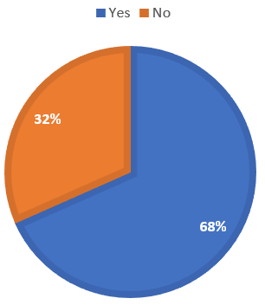
The great majority of people appear to be adhering to the current policy, although a significant minority are not.

How has hybrid working impacted allocating work and managing your team's performance?
The most popular answers were along the lines that it has been neutral (46 responses) or positive (35 responses). Many fewer people reported that it has been negative (13 responses). Several people reported specific problems with inducting new joiners (4 responses) or managing poor performers in the team (3 responses).
Specific answers included the following:
You have to build a lot of trust in your team as you have to take their word for it if they say something is taking longer than you expect as it is more difficult for them to show you what the challenges are.
Forces you to plan better - allocate work but colleagues can get hold of you easily on IM or email to check in if they need help
It has changed the way that we engage by relying on digital channels over in person, however it has not affected the team's performance or how that performance is managed (outcome-based). I do not think that my team are all in the office 40% (I have no way to measure without being in the office myself everyday), but unless there are performance concerns this is not an issue for me.
Minimal impact. Just occasional concerns about staff availability/working hours when they appear away for long periods but do not have lunch/meetings/private appointments marked in Outlook. This is more an issue for [REDACTED] where we don’t have good visibility/control of workflow. On the whole though I would say that the overwhelming majority of staff are more productive WFH and I do not have any major concerns. Most of the time it is apparent that our Teams technology is at fault, showing people as away or last logged on yesterday when they are actually at their desks and working, sending emails as normal.
Hybrid works well, as my team feel empowered to be at the location that lets them be most effective - sometimes that is in the office, sometimes not. The minimum requirement feels arbitrary, and has been the only cause of friction, when individuals feel they must come in to do work they could do more effectively from home just to “box tick.”
It hasn’t really made any difference in terms of work allocation or performance. I would say though that most of the team are happier working at home most of the time, but coming in for purpose based activities such as workshops, or where there are sensitive meetings and face-to-face discussion is needed.
Means you really need to keep in touch with your team to understand workload and manage performance. This is a good thing and means I engage more because I have to ask the questions rather than assume workload levels. Equally it's easier to re-allocate work / ringfence individuals to allow individuals space to work on specific projects. Overall the team is happier and performance increased during lockdown, and has stayed at a good level.
My team all wish to work one day a week in the office, which is a reflection of their personal lives, and I suspect if Exco push for more than 40% I will spend the next year trying to hold their line (with weak arguments) with increasingly disaffected staff. That is already set against a backdrop of unhappy staff!

